COPPER CONCENTRATES BUSINESS – NY

Trading

The Concentrates business is essentially the sale of Copper Concentrate (raw material direct from the mines, made up of Copper, Silver, Gold and impurities) to Smelters. This is a global business with most procurements from USA, Indonesia and Papua New Guinea, and most of the sales to China, Korea, India, Japan & USA. Although the concentrate is usually sold directly to the Smelters, it is sometimes advantageous to both parties that MG own the product and use the Smelter’s excess capacity to convert the product for their own use.

Purchases and Sales are made on the basis of quoted exchange metal prices at the QP (Quotation Period) as laid out in the contract. The purchase price is based on the price at the purchase QP less a percentage for TC (treatment cost), RC (refinery cost), transport and impurities. All contracts are hedged on the exchange. The company therefore derive their profit from
- TC/RC differentials
- Hedging the Spread
- Savings on transportation

All deal capture is through the Lotus notes shipping schedule. When a contract is signed it is entered into the manual contract log book and given a contract number. It takes several months to set up a contract which will typically cover several deliveries over a period of years. Traditionally there is a mating season in Q4 in which the majority of contracts are signed. Contracts are full and detailed including delivery dates, QPs, amounts (vol & pricing basis), payment terms, provisions for analysis of the product and settlement of disputes. Contracts are usually under English law in the international field, although there are some exceptions (eg US, Sweden…)

Contracts are managed in 10,000 tonne quotas. Sales and purchases are married individually and allocated a married contract number (internal order) based on the purchase contract. They are entered into the Aquarius system which is the basis of the contract management. All of the contract details including deductions (impurities and shrinkage), TC and RC are followed for each contract.

A typical contract in a contango market may be as follows;

January – Purchase QP
March – Shipment from ChileMarch – Provisional invoicing (opens up letter of credit) for 90% of estimated total
April – Arrival in China
April – Payment released
August – Sales QP – final settlement.

Delivery volume in terms of metal content is not expected to be exact – there is a tolerance of +/- 10% on all shipments. A final invoice is only possible several months after shipment arrives and tests of metal content have returned and been agreed.

Organisation

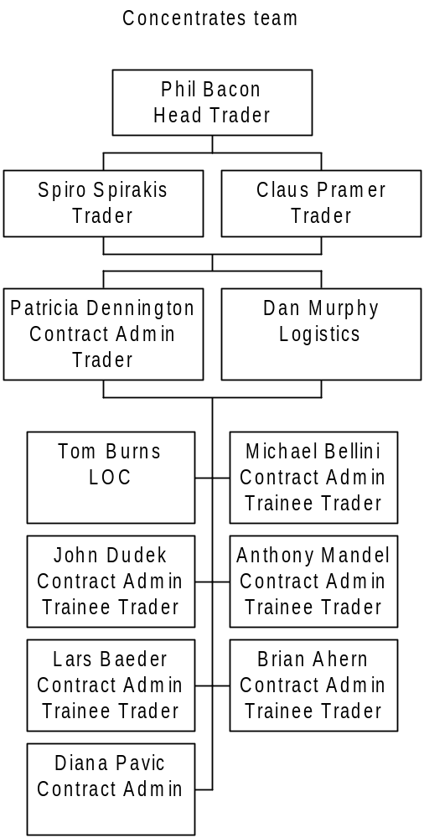

The organisation is such that all traders learn their business via contract admin. For each contract there is a single contract administrator named to manage that contract through the various stages – logistics, letter of credit, invoicing, managing QPs….. Each contract administrator has a “buddy” on the contract – someone who knows exactly where the contract is and who can cover in times of absence of the contract administrator.

There is a shared lotus notes e-mail address for all correspondence relating to contracts – this is viewed by all of the team and Marcelo Parra also has access.

Contract Admin

Each married contract is allocated to a contract administrator who has full responsibility for following the whole contract through from start to finish. Contracts are allocated on the basis of workload and it is possible (although not frequent) that the trader who booked the sale could be the same person as the contract administrator.

Specific responsibility and overall management of specific items are also laid out in the team;
Eg Dan Murphy has overall responsibility for logistics and shipping, Tom Burns has overall responsibility for Letters of Credit, Brian Ahern prepares contracts and Patricia Dennington manages all hedging.

Remote offices (own reps & agents) are the people on the ground who will help the cp to obtain LOC, provide regular contact with the cp and liaise regularly with the contract administrators in NY. They may become involved in negotiations, but are given very small margins for manoeuvre. Contracts are only valid in writing and these are issued from NY. Main reps are in China, India, Chile & Japan.

Contract administrators are responsible for entering contract information into Aquarius. This is then validated by the trader. They monitor QPs via a market card (one for Copper, one for Silver and one for Gold) and Patricia Dennington will hedge accordingly on the futures market.

The contract administrators have responsibility for collecting the relevant documentation on purchase – original documentation from suppliers denoting the weight and quality of material, invoices from suppliers, BOL (bill of lading), Certificate of Origin, Assay Certificateetc. They are also responsible for ensuring insurance – this may vary from cp to cp – most insurance is covered by the cp, but some will be through MG’s own insurance company.

Nb opportunity for synergy – current terms & conditions were established by MG Frankfurt. The insurance co is Allianz – they are having some difficulties in obtaining details.

Contract administrators are also responsible for collecting and issuing Sales documentation – issue of invoices (1st provisional, sometimes 2nd provisional and finalisation), LOC documentation (ships are normally only loaded when this has come through). The original purchase documents are sent to the cp along with the 1st provisional invoice (normally 90% of estimated sales price) in order to open the LOC.

A vessel is chartered and representation at port is nominated for Assay survey service. Depending on the contract and the cp, this may be at both loading and delivery ports. The Assay survey takes samples for analysis of metal content, impurities and water content on loading. In most cases the smelter takes weights on receipt and sends samples for Assay. It takes approximately 6 weeks for the analysis to be returned and finalisation of invoicing can then take place. Disputes are settled by arbitrator named in the contract.

Vessel scheduling is followed on an excel table which is updated once per month.

LOCs are followed on an excel schedule which is updated once per month.

Accounting and Risk Management

There is no traditional risk management function within the team The positions are uploaded to Mercur daily and reviewed on a market risk basis. Detailed validation of those figures is a monthly process.

Sales and purchase invoices are maintained in Aquarius by the contract admin team and manually input into SAP on a daily basis by a data input accountant.

Frank Mastromatteo from the accounting team prepares a daily position report for each metal, based on the market card. The position is derived from Net Physical less terminal market. The position is only validated by analysis once per week.

Frank also books monthly MTM adjustments and provisions to provide the monthly P&L. In order to do this, he copies down the live Aquarius database into a separate accounting section within the Aquarius system (known as M1), thereby freezing the information. He then validates information on a contract by contract basis.

Terminal market prices are validated to LME and Comex rates for Copper, Silver & Gold. The Aquarius system provides the forward curves based on the market information that has been input. These are then checked to broker statements for reasonableness.

Physical deals are checked by review of the P&L for each married contract for reasonableness. Once spurious information has been removed (eg Frame contracts which are merely heads of agreement) and unmarried contracts have been married to a pro-forma contract based on market price estimates, he downloads the information on M1 in Aquarius to an excel spreadsheet. He then provides a P & L;

Sales
- Purchases
= Physical

- Accruals
+/- Terminal mkt
- General Reserve (management judgement)
- Spread Reserve (if Spreads are collapsing)
= Gross Margin

He then updates the information in SAP by manual input. Provisional invoicing to cps is adjusted to the balance sheet and MTM Income is booked. Accruals are booked for purchases not yet invoiced based on the MTM information.

This then forms the basis of the full monthly P&L which is produced in SAP.

A download from Aquarius M1 and SAP is then taken into Mercur in order to pull all the MG figures in for global risk management analysis.

The monthly management report includes variance and sensitivity analysis as well as TC/RC monitoring. (see attached).

